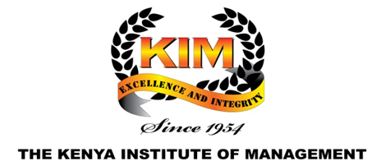

**SENIOR MANAGEMENT COURSE CONTENT**

|  |  |
| --- | --- |
| **MODULE ONE** | **FACILITATOR** |
| **MANAGEMENT PRINCIPLES AND PRACTICES** |  |
| 1. Overview of Management 2. Decision Making and Problem Solving 3. Effective Delegation 4. Effective Management of Human Resource 5. Succession Planning Strategies 6. Approaches to Staff Motivation |  |
| **MODULE TWO** |  |
| **DEVELOPMENT PLANNING AND PUBLIC POLICY** |  |
| 1. Public Policy formulation and implementation 2. Development Planning- History of Development Planning and the role of KV 2030 in development 3. Development Planning- Processes and linkages of national and county planning 4. Strategic Planning 5. Project Management |  |
| **MODULE THREE** |  |
| **MANAGEMENT COMMUNICATION - PS Induction Handbook** |  |
| 1. Interpersonal Communication 2. Public Service Etiquette – [Customer Service etiquette](https://www.indeed.com/career-advice/career-development/customer-service-etiquette#:~:text=Customer%20service%20etiquette%20refers%20to,a%20high%20standard%20of%20service.), [Office etiquette](https://www.careerpointkenya.co.ke/2017/08/8-important-office-etiquette-you-must-have/) 3. Management of Meetings 4. Interviewing Skills 5. Presentation Skills 6. Effective Office Communication 7. Negotiation Skills |  |
| **MODULE FOUR** |  |
| **EFFECTIVE LEADERSHIP** |  |
| 1. Leadership in the Public Service 2. Managing Teams 3. Risk Management 4. Managing and Leading Change |  |
| **MODULE FIVE** |  |
| **GOOD GOVERNMENT AND SUSTAINABLE DEVELOPMENT** |  |
| 1. Good governance 2. Constitutionalism and Rule of Law 3. The Devolved Government Structure and Institutions 4. Public Service Ethics and Integrity 5. International Relations and Regional Integration |  |
| **MODULE SIX** |  |
| **PUBLIC RESOURCE MANAGEMENT** |  |
| 1. Introduction to Public financial management 2. The Budget and Budgetary Process 3. Program Based Budgeting 4. Public Auditing 5. Public Procurement |  |
| **MODULE SEVEN** |  |
| **PUBLIC SECTOR REFORMS AND EMERGING ISSUES** |  |
| 1. Overview of Public Sector Reforms 2. Performance Management 3. Disaster Management 4. Diversity Management at the workplace 5. e-Government |  |
| **MODULE EIGHT** |  |
| **RESEARCH PROJECT** |  |